DSBA 6211 Assignment 3
Dataset Description:
The “ita_wine_reviews.csv” dataset contains detailed evaluations of Italian wines written by professional critics, along with structured metadata about each wine. Each observation includes a textual description of the wine’s taste, aroma, and quality, along with numerical and categorical attributes such as points (ratings), designation, price, province, variety, and winery.
Submission Requirements:
Provide a Word document that shows the result of the specified tasks and answers to the specific questions below:
Tasks to complete:
- Text Preprocessing: Preprocess the text data in the “description” column. Include tokenization, lowercasing, stopword removal, and any other necessary steps (e.g., punctuation removal, stemming/lemmatization).
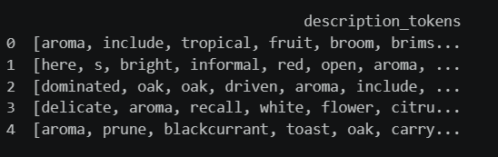
- Word Clouds: Create a word cloud for the “description” column after preprocessing.
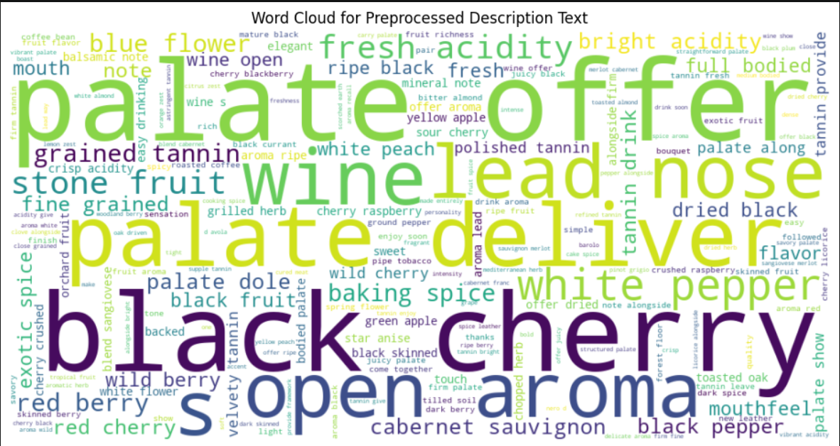
- Term Similarity Analysis: Perform text mining to find the top 5 terms that are most related (similar) to the following seed words:
  - “fruit”,
  - “oak”
  - “finish”
Specify the similarity measurement method used (e.g., Cosine Similarity) and provide detailed results.
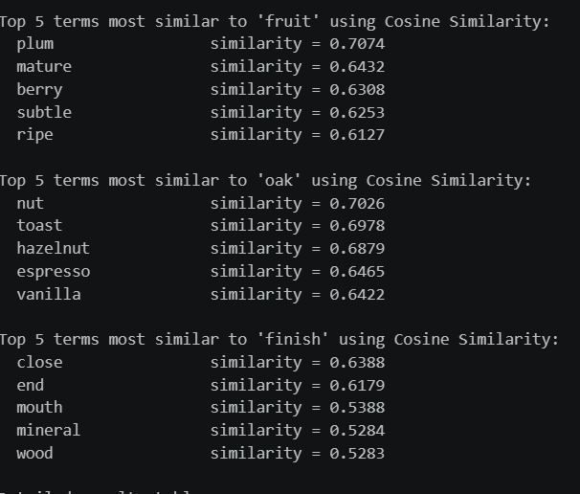
- Topic Modeling (Visualization & Interpretation): Apply topic modeling with 3 topics (or more, if appropriate) to the preprocessed text data. Provide an Intertopic Distance Map, list the top 10 words per topic, and summarize the three topics based on your best effort.
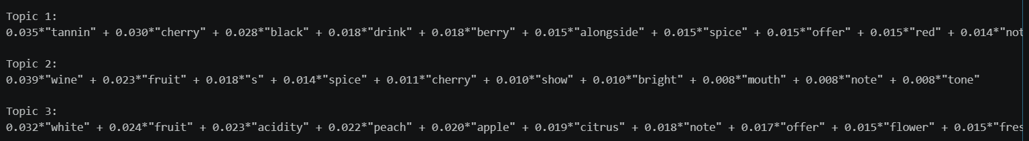
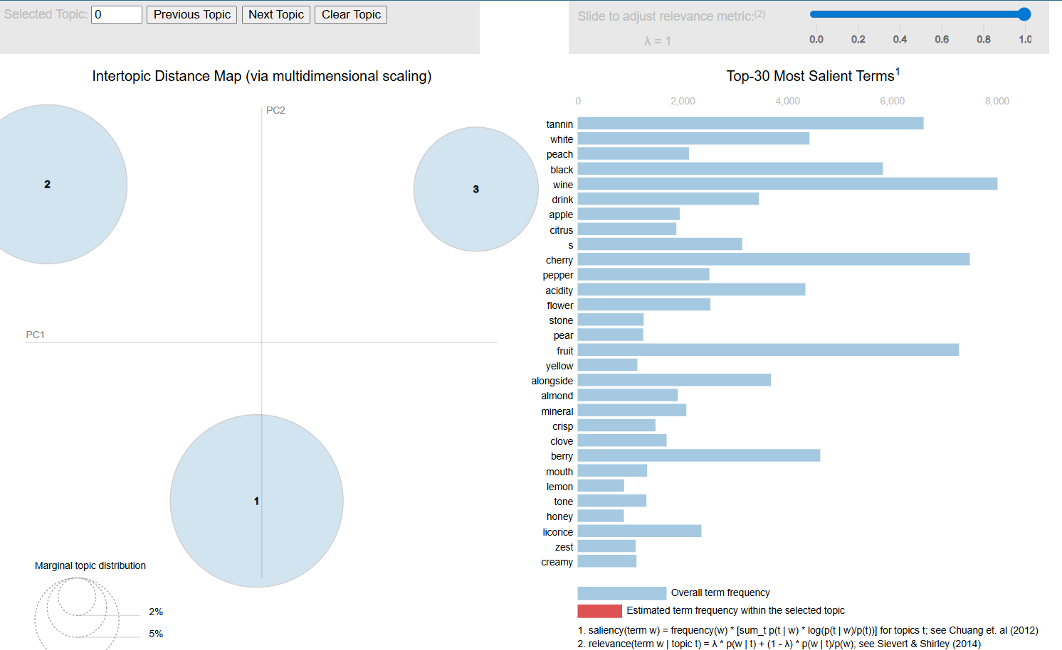
Topic 1: Appears to represent red wines with dark fruits and tannins. The topic could possibly be labeled “Bold red wines with dark fruit and tannic structure”
Topic 2: Captures a more general wine description. There is more fruit and some spice with words like bright and mouth. A possible topic label could be “Balanced fruit-based wines with spice and bright color”
Topic 3: Clearly represents white wines with fruity fresh acidic taste. Possible label could be “Fresh White wines with citric and floral notes”.

- Target Variable & Prediction Models: Build two prediction models for the "Top Rated" (points>=90). Explore the categorical features and decide whether to bucket values into broader categories before dummy encoding.
  - Model 1: Use only non-text information (i.e., exclude “Description” from the dataset).

  - Model 2: Combine non-text information with text information. Perform topic modeling with the LSI model the “description” column (keep the number of SVD components as 5) and use the resulting features to build your model.
- Random Forest Modeling: Create Random Forest models for both Model 1 and Model 2.
- Model Comparison: Compare the performance of the two models based on the AUCROC of the validation set. Draw ROC curves for each model to provide a visual comparison.
- Alternative Classifier: Repeat tasks 6 and 7 with your choice of any other classifier (e.g., SVM, XGBoost). To manage computation time for hyperparameter tuning:
  - You may use a smaller, randomly sampled subset of the training data for tuning.
  - Alternatively, you may use a more efficient search method such as Randomized Search instead of Grid Search.
  - You are encouraged to consult GenAI for other approaches. If you do, remember to include the specific prompts you used submission and clearly state and justify your approach (categorization, sampling, search method) in your Word Document submission.
Notebook Submissions (2 Required):
Download and submit the Word Document and Google Colab notebook (ipynb) with your completed code and output. To upload multiple documents on Canvas, click the File Upload button in the assignment, then click Add Another File for the second upload.
Note on the Use of AI:
The use of GenAI is expected and recommended. Please share specific prompts you used (other than the task descriptions above in this assignment), such as “What should I do if I have too many categories in a categorical feature?” or “How do I create a smaller sample for hyperparameter tuning when the training set is too large?” It is also very important that you understand the code that is generated by AI. Do not use the code if you do not understand it.

